ResuMate – AI Powered Recruitment Automation Platform

1. Introduction

1.1 Purpose of the Document
This document provides complete and detailed documentation for ResuMate, an AI powered recruitment and resume analysis tool.
It is intended for:
- Product stakeholders
- HR teams and recruiters
- Developers and technical teams
- Management and decision makers
The documentation explains what the tool does, how it works, and how users interact with it, in a professional and easy to understand manner.

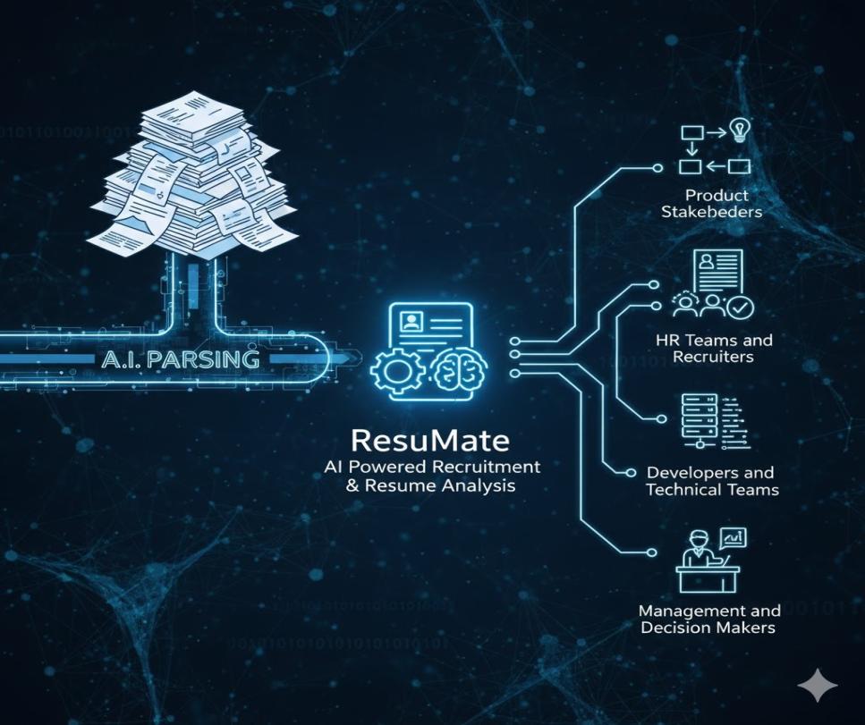

1.2 Product Overview
ResuMate is an intelligent recruitment platform designed to help HR teams and recruiters automatically identify the most suitable candidates for a specific job role using Artificial Intelligence.
The platform analyzes job descriptions and resumes, calculates ATS (Applicant Tracking System) scores, matches skills and experience, and generates clear candidate reports — all with minimal manual effort.
The frontend UI is built using React, while AI and automation handle resume parsing, scoring, and matching in the backend using N8N.

2. Key Objectives of ResuMate
- Reduce manual resume screening time
- Improve hiring accuracy and consistency
- Eliminate bias through data driven evaluation
- Provide ATS compliant scoring and insights
- Enable faster shortlisting and decision making

3. User Roles

3.1 Recruiter / HR Admin
- Create job descriptions
- Upload or receive resumes via Emails or Bulk upload
- Initiate resume scanning
- View candidate reports and scores
- Export reports and manage hiring data

3.2 System (AI Engine)
- Parse job descriptions
- Extract resume data
- Match skills, experience, and keywords
- Calculate ATS and match scores
- Generate structured reports

4. Application Flow Overview
- Recruiter logs into ResuMate
- Creates or uploads a job description
- Adds candidate resumes (email or bulk upload)
- AI processes and analyzes resumes
- System generates ATS scores and match results
- Recruiter reviews candidate reports
- Final shortlisting decision is made
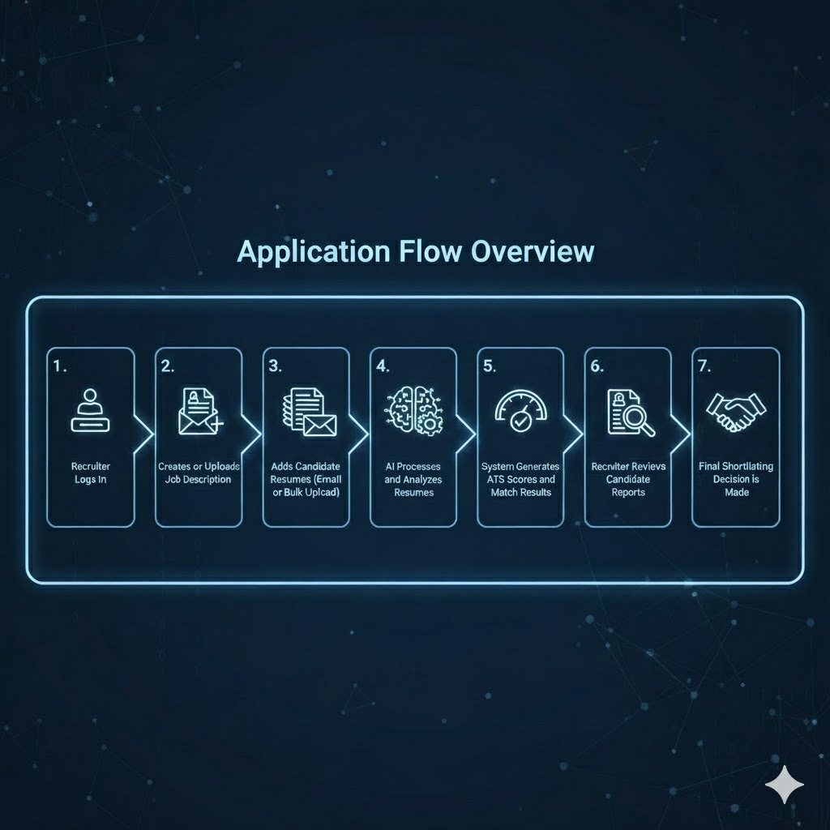

5. Dashboard Module

5.1 Dashboard Overview
The dashboard is the central control panel of ResuMate. It provides a real time overview of recruitment activity.
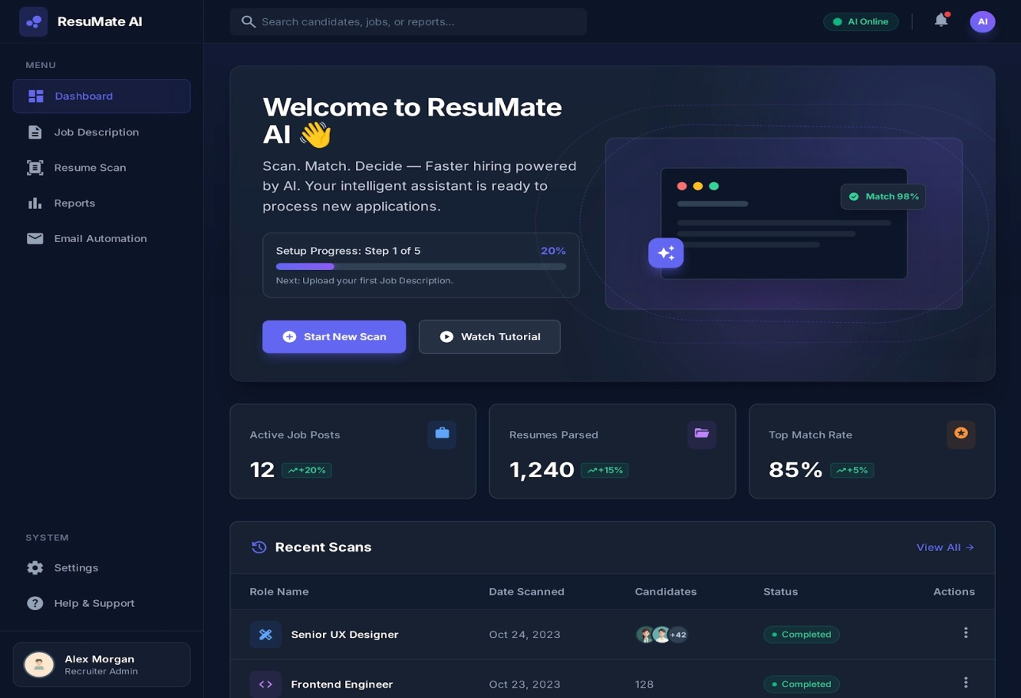

5.2 Key Elements
- Welcome section with onboarding progress
- Active job posts count
- Total resumes parsed
- Top match rate percentage
- Recent scans list

5.3 Benefits
- Quick visibility into hiring performance
- Easy navigation to all modules
- Status tracking for ongoing scans

6. Job Description Module

6.1 Purpose
This module allows recruiters to define role requirements, which serve as the foundation for AI based resume matching.

6.2 Job Description Creation Methods

Option 1: Create Your Own
- Drag and drop role elements from the library
- Select job role (e.g., Senior Frontend Developer)
- Define experience range
- Add location and required skills

Option 2: Paste Description
- Paste raw job description text
- AI automatically parses and extracts:
  - Skills
  - Education
  - Experience
  - Keywords
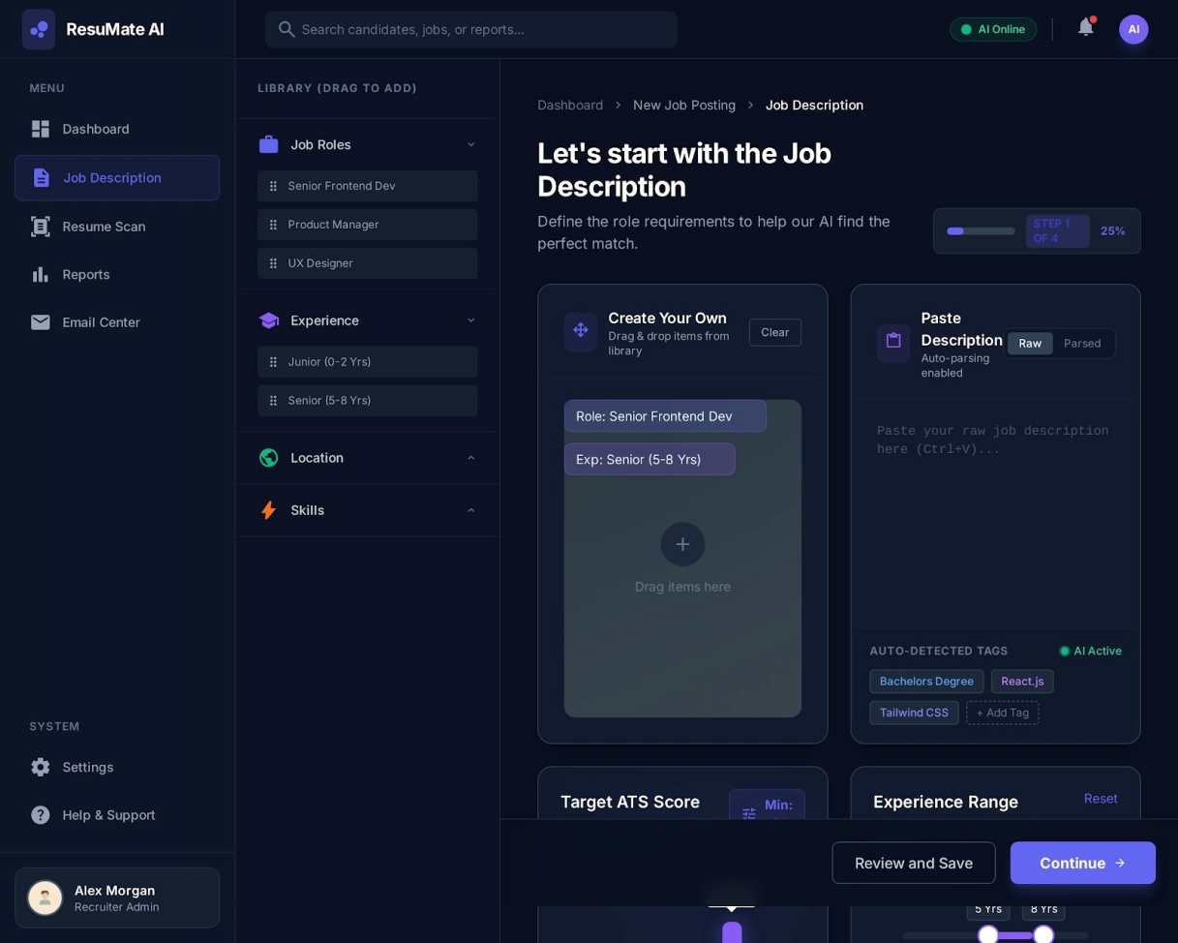

6.3 Auto Detected Tags
- Skills (e.g., React, Tailwind CSS)
- Education requirements
- Experience level

6.4 Output
- Structured job profile
- AI ready matching criteria

7. Resume Scan Module

7.1 Purpose
This module is used to import candidate resumes into the system for analysis.

7.2 Resume Upload Methods

7.2.1 Upload via Email
- Each job gets a dedicated email address
- Recruiters forward candidate resumes
- AI automatically reads email attachments

7.2.2 Bulk Upload
- Upload multiple resumes at once
- Supported formats: PDF, DOC, DOCX
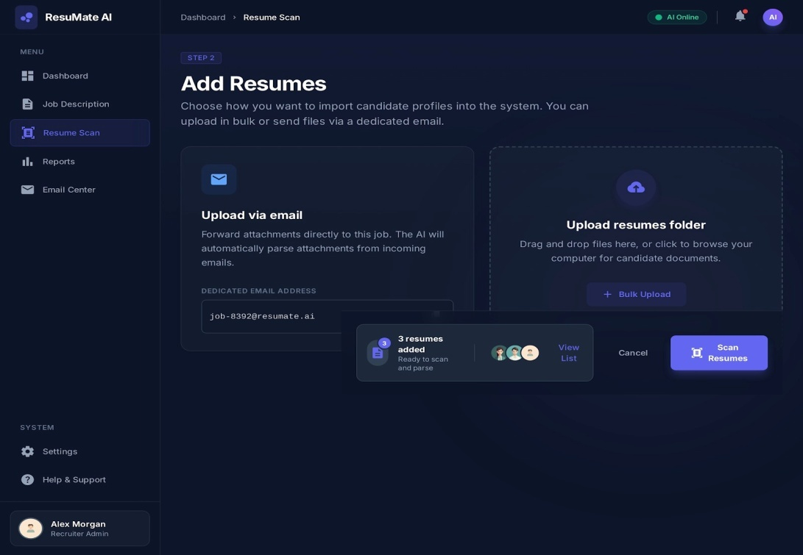

7.3 Resume Status
- Added
- Ready to scan
- Processing
- Completed

8. AI Resume Processing Engine

8.1 Processing Steps
- OCR (Optional Character Recognition) and document parsing
- Resume structure analysis
- Entity extraction:
  - Skills
  - Experience
  - Education
  - Location
- Keyword matching with job description
- ATS score calculation
- Match categorization
- Template-based resume formatting and structuring
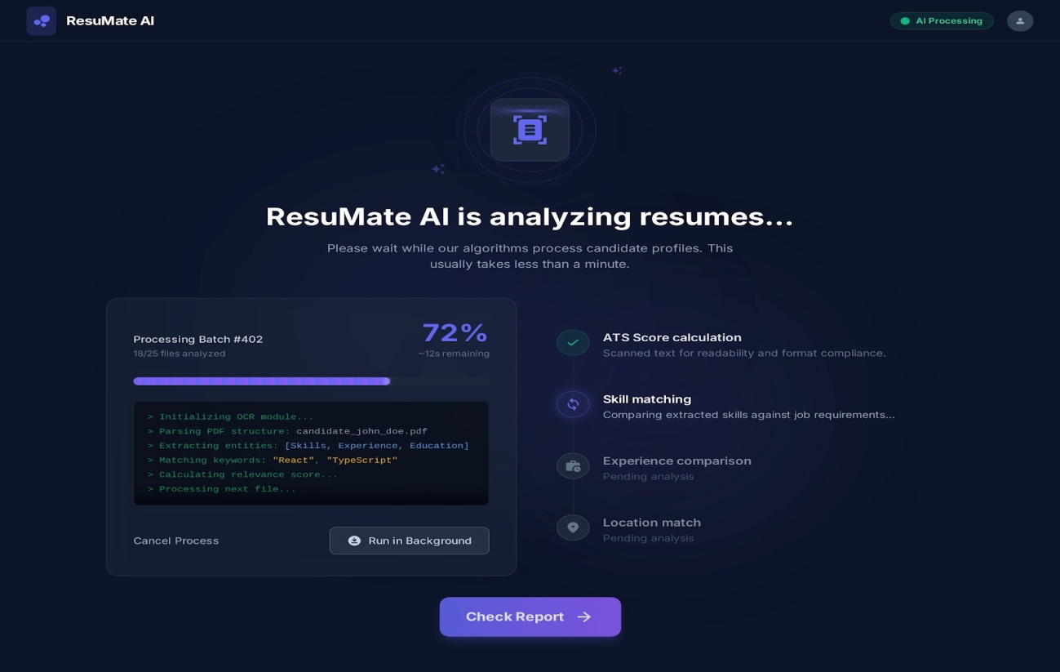

8.2 Template-Based Resume Parsing & Formatting
In addition to analysis and scoring, ResuMate uses predefined resume templates to structure and present candidate data in a clean, professional, and ATS-friendly format.

Why Template-Based Parsing?
- Resumes come in different formats, layouts, and styles
- Inconsistent formatting can reduce ATS readability
- Recruiters need uniform and easy-to-compare candidate profiles
To solve this, ResuMate normalizes all resumes using AI-powered data parsing combined with standardized templates.

How It Works
- Raw resume (PDF/DOC/DOCX) is parsed
- AI extracts structured data:
  - Personal details
  - Skills
  - Work experience
  - Education
  - Certifications
- Extracted data is mapped to a selected resume template
- The template restructures the resume into:
  - Clean sections
  - Consistent layout
  - ATS-optimized formatting

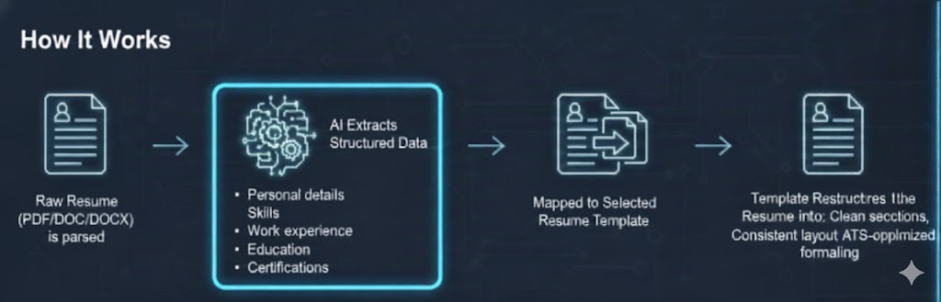

Benefits of Template-Based Resumes
- Professional and uniform resume appearance
- Improved ATS compatibility
- Better readability for recruiters
- Easy side-by-side comparison of candidates
- Reduced bias caused by visual resume design differences
This ensures that every candidate profile looks well-structured and professional, regardless of how the original resume was designed.

8.3 Real Time Processing View
- Progress percentage
- Processing logs
- Background execution option

9. ATS Score Calculation

9.1 What is ATS Score?
ATS score represents how well a resume aligns with the job description and ATS friendly standards.

9.2 Factors Considered
- Keyword relevance
- Skills match
- Experience alignment
- Resume formatting
- Education match

9.3 Score Range
- 0 – 100

10. Candidate Reports Module

10.1 Purpose
Provides a clear, visual comparison of all candidates for a job role.

10.2 Candidate Card Details
- Candidate name and email
- ATS score
- Experience (years)
- Location
- Matched skills

10.3 Match Categories
- Top Candidate
- Strong Match
- Good Match
- Review Needed
- Weak Candidate

10.4 Filters and Search
- Skill based search
- Experience filter
- Location filter
- Match strength filter

10.5 Actions
- View detailed report
- Export CSV
- Start new assessment
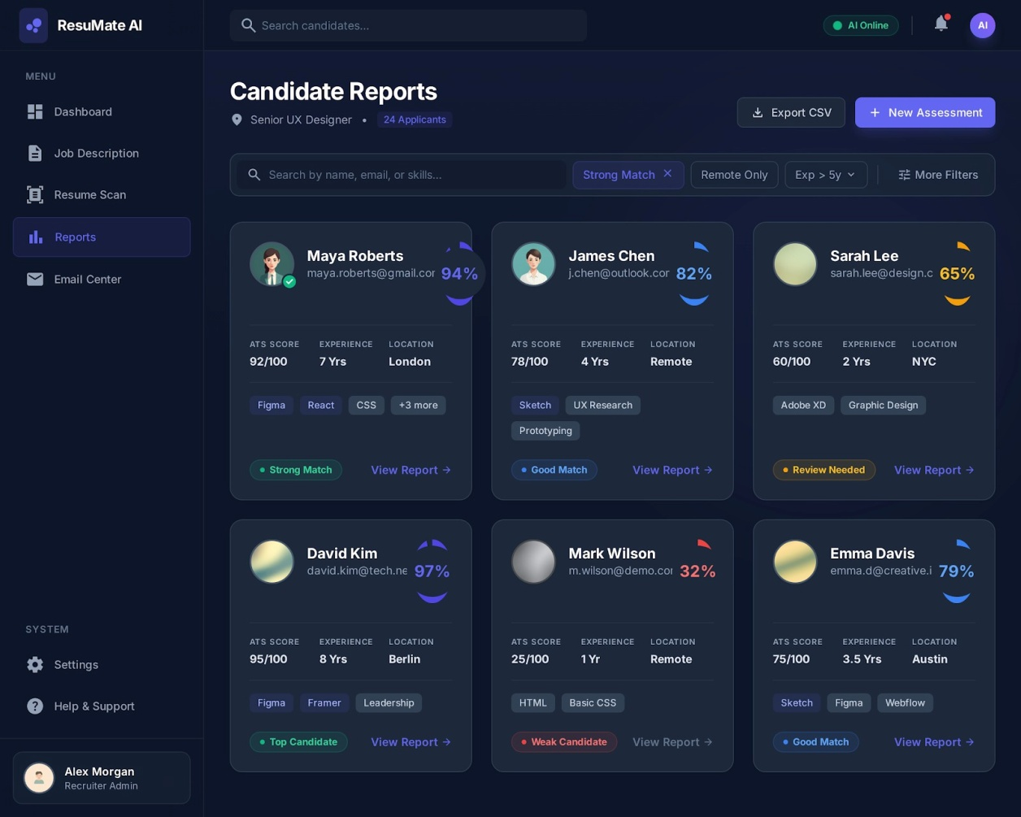

11. Reports & Analytics

11.1 Report Types
- Candidate comparison reports
- ATS performance metrics
- Hiring efficiency reports

11.2 Export Options
- CSV export
- Data sharing with stakeholders
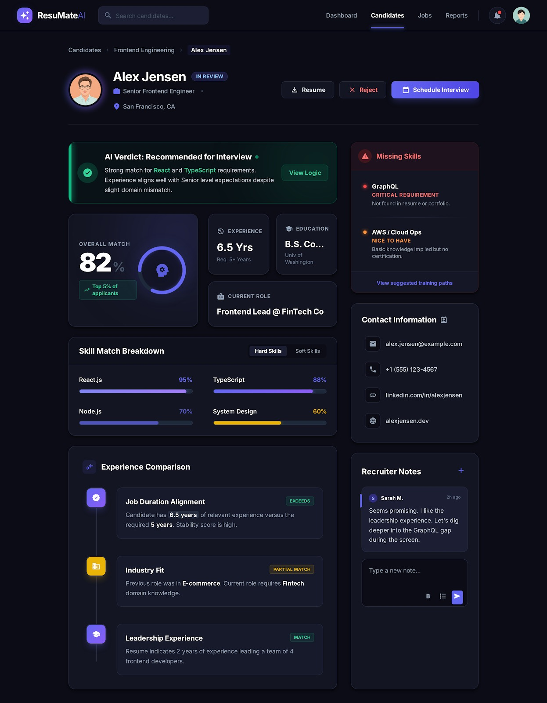

12. Email Automation Module

12.1 Purpose of the Module
- Automate candidate communication workflows
- Maintain consistent and professional email messaging
- Reduce recruiter workload and response time
- Improve candidate experience through timely updates

Key Features and Functionalities
Candidate Context Display
- Shows candidate name, email, applied role, hiring status, and AI match score
- Provides full context before sending emails
AI-Generated Email Draft
- Automatically generates selection or rejection emails
- Uses professional, industry-standard language
Editable Email Composer
- Recruiters can edit recipients, subject, and email content
- Supports basic text formatting for customization
AI Writing Assistance
- Make Friendlier adjusts tone
- Shorten reduces length while keeping key information
Status Indicators
- “AI Draft Ready” confirms email is prepared
- “AI Online” indicates AI services are active

12.2 Selection and Rejection emails
Selection Email
The Selection Email is used when a candidate has been successfully chosen for the role. This email serves as a formal offer communication and is typically sent after final interview evaluation. The AI generates a professional draft that includes:
- A clear subject line indicating an employment offer
- A personalized greeting addressing the candidate by name
- Confirmation of the selected role and organization
- Positive acknowledgment of the candidate’s interview performance or portfolio
- Reference to an attached formal offer letter containing compensation, benefits, and start date
- A closing section inviting the candidate to ask questions or confirm next steps
Rejection Email
The Rejection Email is used to inform candidates who are not selected for the position. While concise, this communication plays a critical role in maintaining the organization’s employer brand. The AI-generated rejection email typically includes:
- A neutral and respectful subject line
- Appreciation for the candidate’s time and interest in the role
- A clear but courteous notification that the organization has decided to move forward with other candidates
- Encouragement to apply for future opportunities when appropriate
- A professional closing signed by the recruiter or hiring team

12.3 Use Cases
- Resume intake via email
- Candidate status notifications
- Interview invitations (future enhancement)

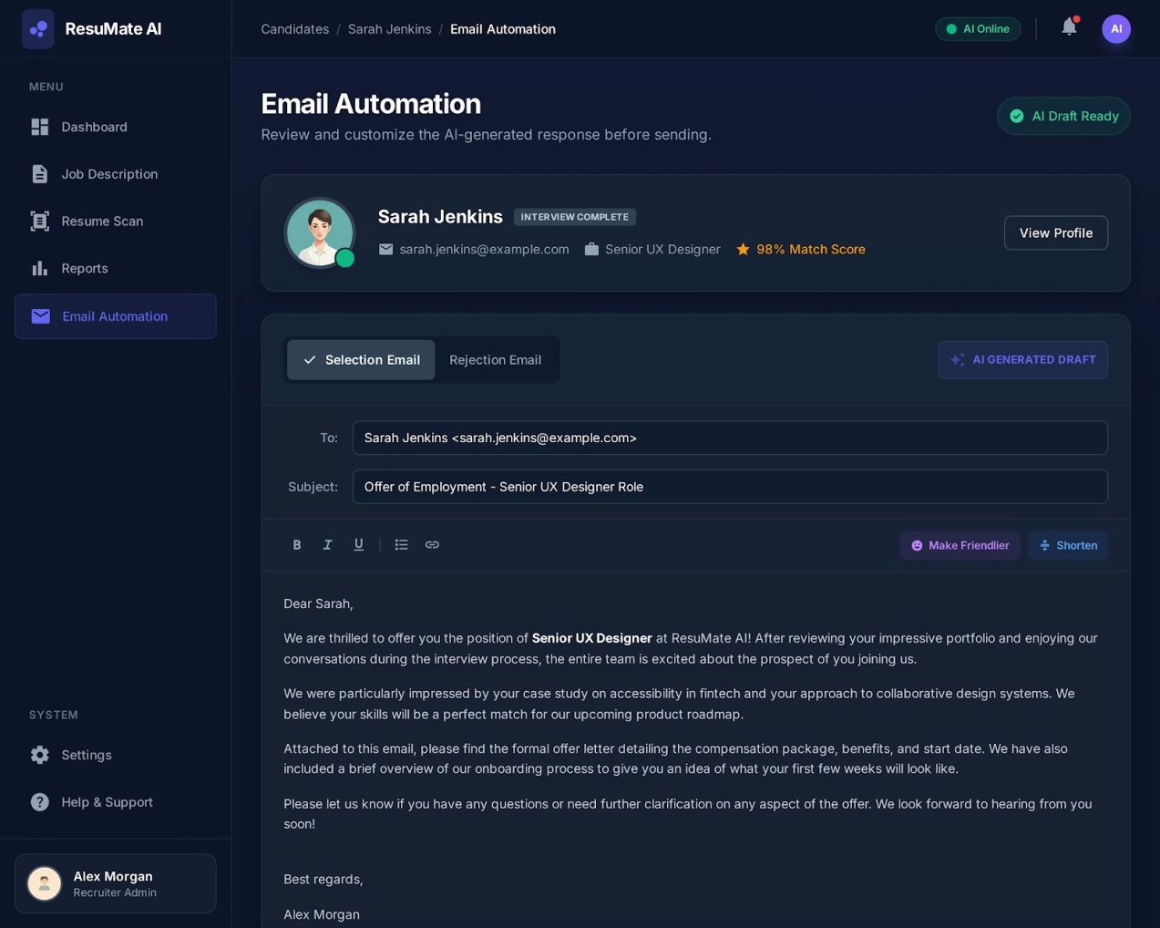

13. System Architecture

13.1 Frontend Architecture (React)
Technology Stack
- React.js
- Component based architecture
- Reusable UI components
- State management (Context / Redux)

UI Principles
- Dark modern UI
- High readability
- Minimal learning curve
- Responsive design

13.2 Backend Architecture
Technology Stack
- n8n – Workflow automation and AI orchestration
- Java – Business logic and service layer
- Mongo DB – Resume, job, and candidate data storage
- REST APIs – Secure communication between frontend and backend
Backend Responsibilities
- Resume ingestion and processing workflows
- AI resume parsing and ATS score calculation
- Job–resume matching logic
- Report generation and data export
- Email automation and background processing

13.3 Frontend–Backend Interaction
- Frontend communicates with backend via secure REST APIs
- Backend processes requests and triggers n8n workflows
- Mongo DB stores structured resumes, scores, and reports
- Results are returned to frontend in real time
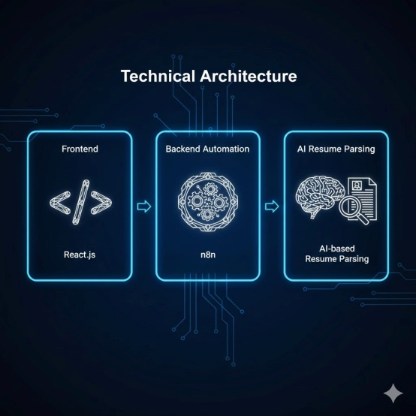

14. Security & Compliance
- Secure resume storage
- Role based access
- Data encryption
- GDPR (General Data Protection Regulation) ready architecture

15. Benefits for HR & Recruiters
- 70–80% reduction in screening time
- Consistent candidate evaluation
- Improved hiring quality
- Data driven decisions
- Scalable recruitment process

16. Future Enhancements
- Interview scheduling automation
- AI interview scoring
- Integration with job portals
- Advanced analytics dashboards
- Multi language resume support

17. Conclusion
ResuMate is a complete AI driven recruitment solution that transforms traditional hiring into a fast, accurate, and intelligent process. By combining a modern React based UI with powerful AI automation using N8N , ResuMate enables HR teams to focus on what truly matters — hiring the right talent, faster.

